**Section 1: Introduction To Integration Architect**

Integration Architect is a person who is responsible for designing n architecting integration solution whenever a new requirement comes architect is the person who actually communicates n gathers the business needs n tries to design a soln.When he gets the complete idea of business need n the ideal integration solution he creates a design doc which includes both functional n non-functional requirements of the business and the right integration pattern or approach that will be suitable for the particular business requirements like pub-sub(async),request-reply(sync),event based models like schedulers-based models etc.He should be able to decide deployment approach,best development practices.As an Architect we should provide reusable common components, frameworks like common-fragments,common error-handling framework which can be used by development teams in multiple apps .Architect is responsible for quality n governance n operations of the integration solns.Architect is responsible for advising development team on performance reliability ,guranteed delivery, scalability,monitoring n other operations concerns of an integration solns.Architect should advice or recommend right technologies which each and every team can use .

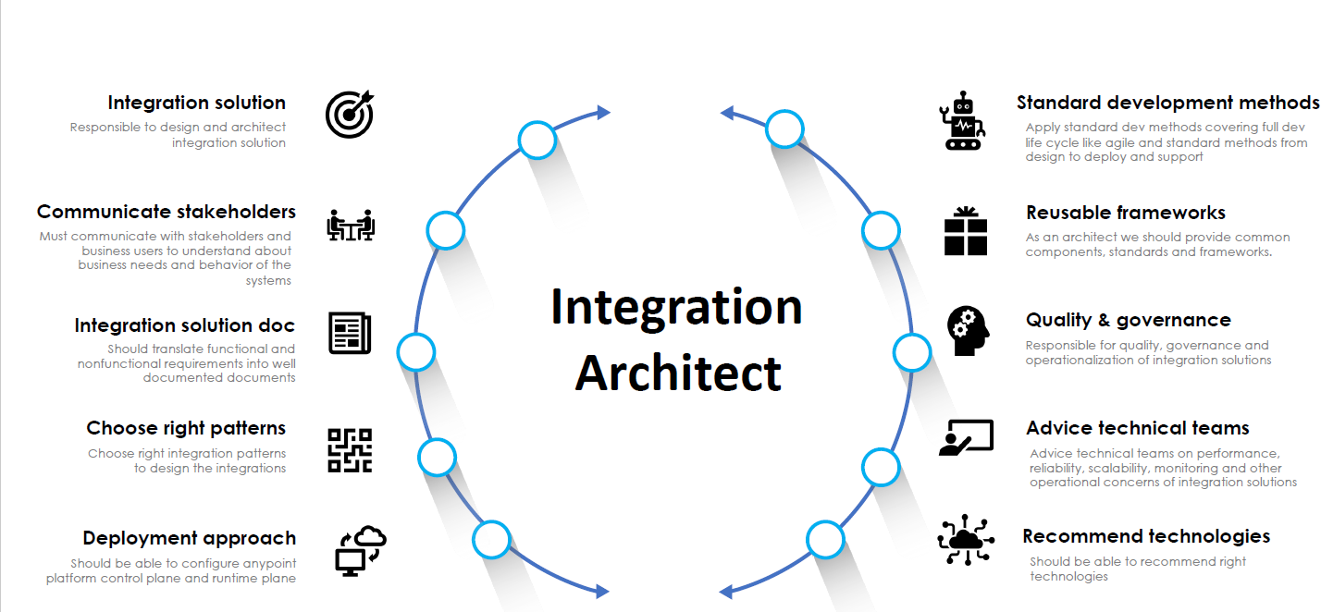

**New Business Requirement:**

Lets assume **health dept of india** has contacted my organization to develop few integration soluns Where they **need to send some information** like current active covid cases in india, current deaths n current no of ppl got vaccinated in india **to WHO(World health Org)**

**Section 2: Theoretical intro to architect and design integration soluns**

**In the above case study, W.H.O will be a source which triggers a request, We(integration Team) as a middleware Technology Team and Health Dept Of India will be target which sends required data back to source**

**Integration Soln and case study intro:**

As an architect we should closely work with business analyst to

-**identify stakeholders**(People involved in an integration project like ppl from source n target systems n the middleware dev team )

-organize **meeting with all stakeholders to get details on functional,non-functional n the service level agreements**

-Once we get details then we need to **identify objectives of integration soln** n also **prepare architectural n UML diagrams to present those business requirements understanding which we understood to stakeholders** becoz many stakeholders can be from technical or not technical background so few may not understand the technical terms so we need to get all stakeholders on same page n get the design, functional, non-functional n service level agreements approved from all stakeholders.

- **once we get all approved then we need to document** the design, functional, non-functional n service level agreements in an integration soln document

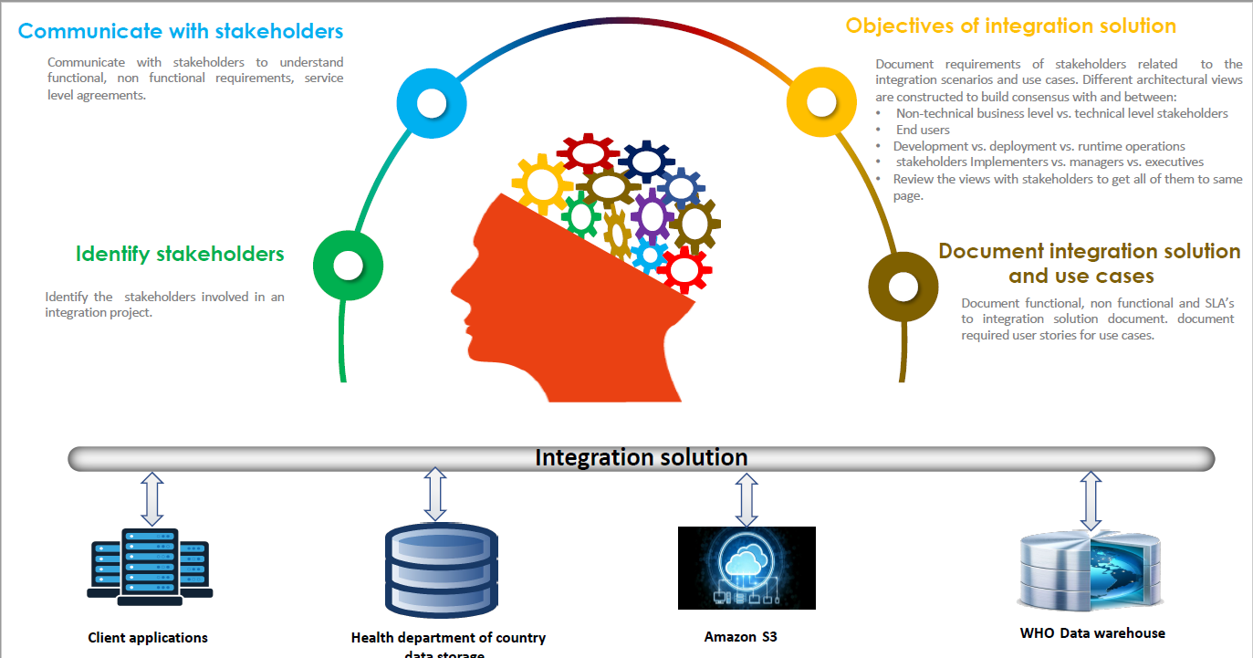

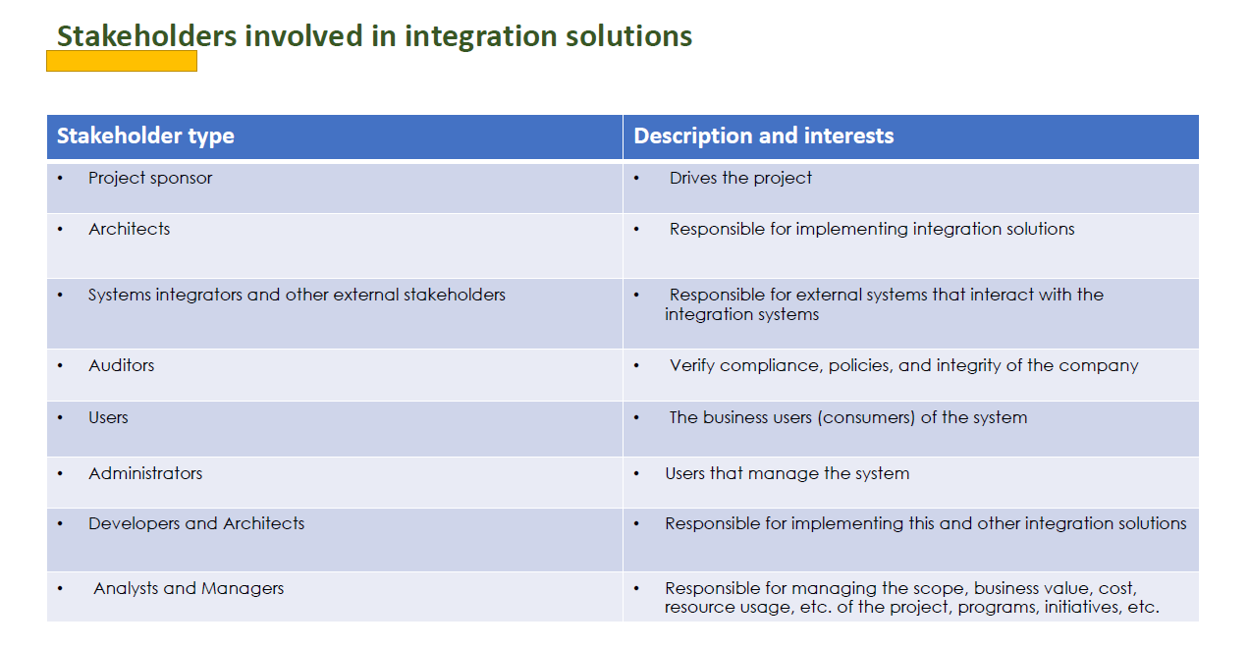

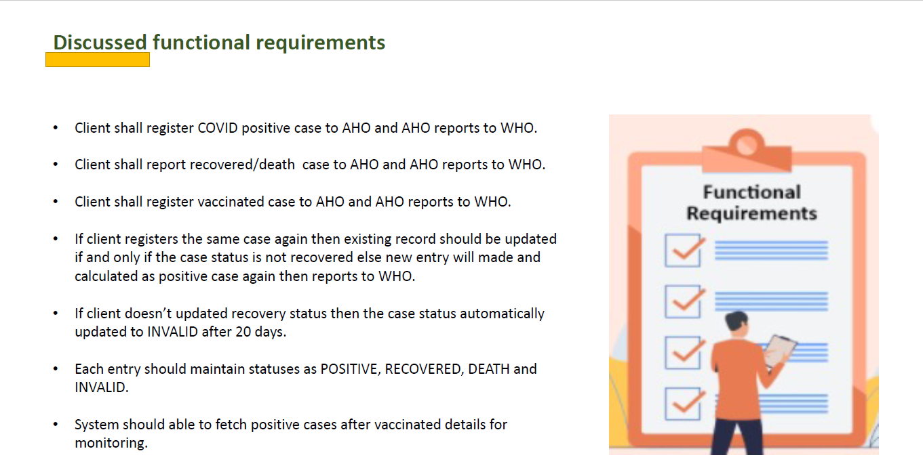

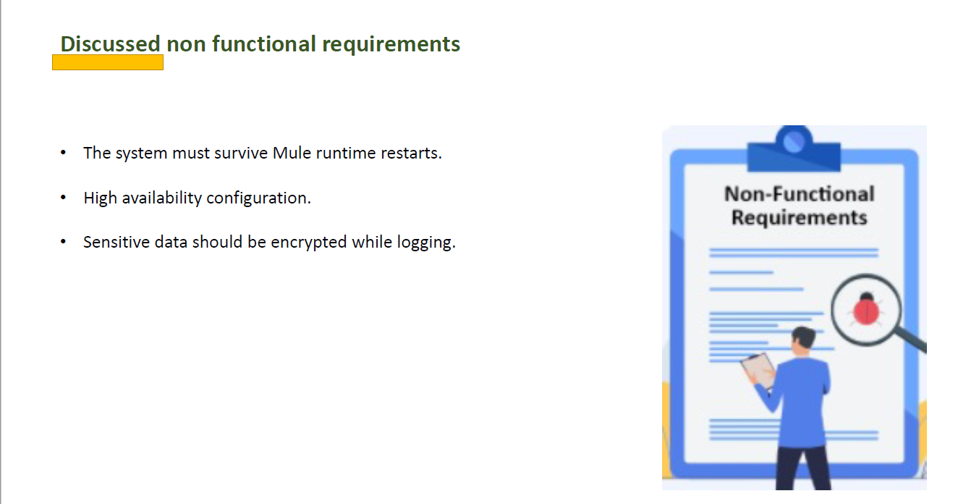 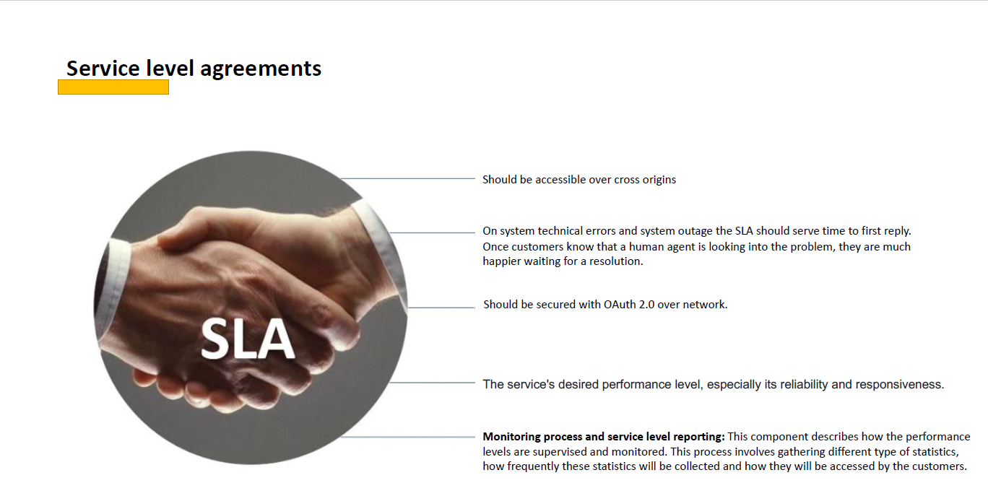

Cross-origin refers to allowing or restricting access to our integration solution resources that we are gonna develop from other domains.for eg: our website is hosted on Suryakant.github.io so to make it cross origin i.e. acceesible from diff domains we need to add few http headers in our server

### To ensure an integration solution is accessible across different origins (domains), you need to enable Cross-Origin Resource Sharing (CORS). Steps to Enable CORS

1. **Server-Side Configuration:**
   * The server hosting the resource must include specific HTTP headers in its responses to indicate that it allows cross-origin requests.
   * Common headers include:
     + Access-Control-Allow-Origin: Specifies which origins are allowed to access the resource.
     + Access-Control-Allow-Methods: Specifies the HTTP methods (e.g., GET, POST) that are allowed.
     + Access-Control-Allow-Headers: Specifies which headers can be used in the actual request.

**Example Configuration:**

* **Apache:** Add the following to your .htaccess file or server configuration:

Apache config

Header set Access-Control-Allow-Origin "*"

Header set Access-Control-Allow-Methods "GET, POST, OPTIONS"

Header set Access-Control-Allow-Headers "Content-Type"

### Best Practices

* **Restrict Origins:** Instead of using *, specify the exact origins that are allowed to access your resources to enhance security.
* **Preflight Requests:** For certain types of requests (e.g., those with custom headers or methods other than GET/POST), browsers will send a preflight request using the OPTIONS method to check if the actual request is allowed.
* **Security Considerations:** Ensure that enabling CORS does not expose sensitive data or functionalities to unauthorized domains.

### Conclusion

By configuring your server to include the appropriate CORS headers, you can control which external domains are allowed to access your resources, thereby making your integration solution accessible cross-origin. This setup is crucial for enabling web applications to interact with APIs and resources hosted on different domains securely and efficiently.

**Architecting with 4+1 Views:**

Once we get our functional,non-functional requirements,sla approved by all stakeholders we should document all those in integration solution doc n to document those we must follow 4+1 view architecting style which includes **logical view(end user view),development view(developer iew),process view(system integrators view),physical view(physical view of systems) n** 1 view is **Scenarios view** which we can call it as **user stories (agile methodology term) which is result of creating all 4 view mentioned earlier**…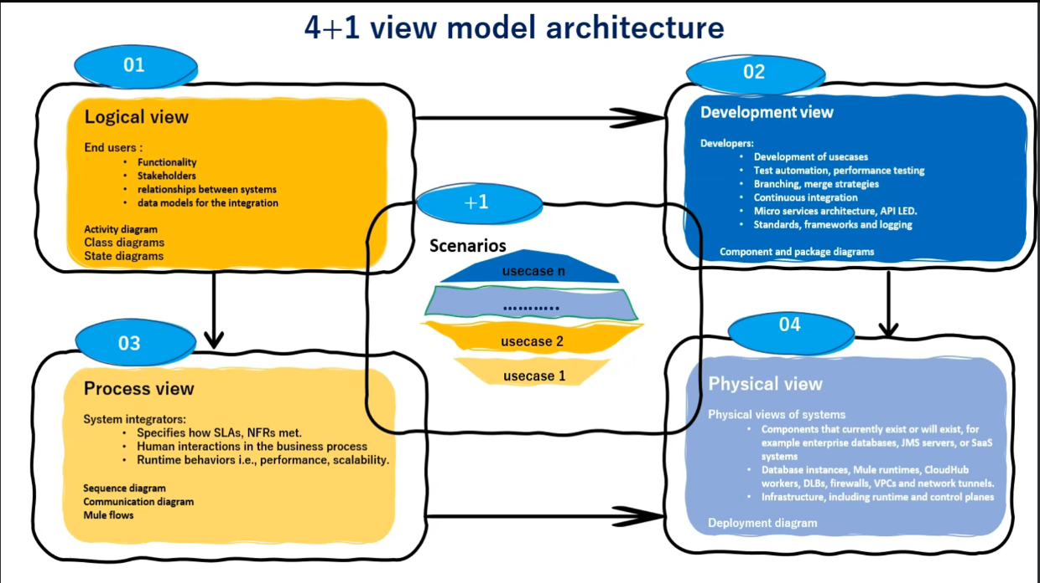

-Logical View example(state Diagram):

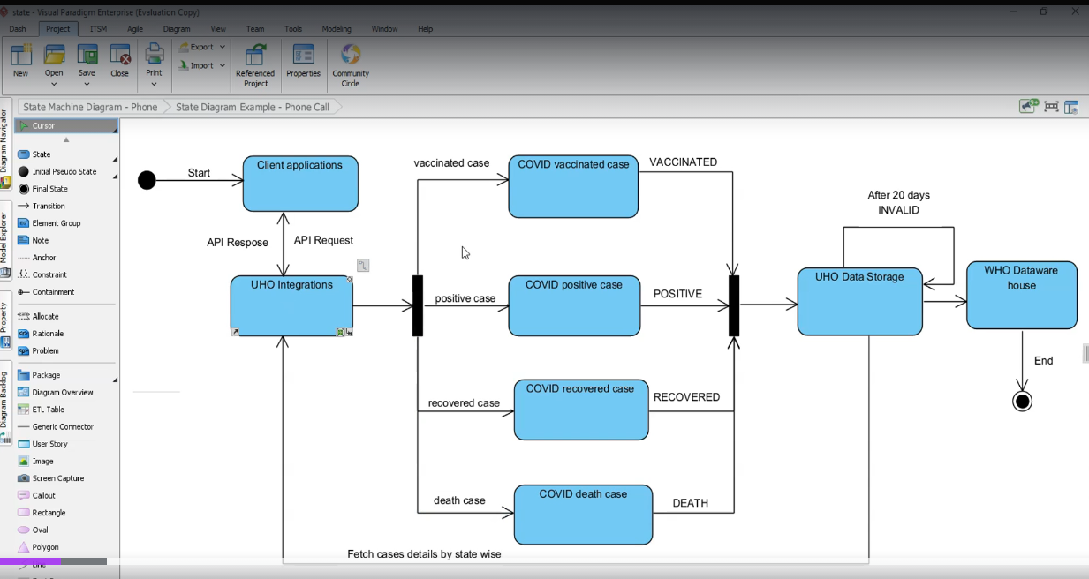

-Process View Example(Sequence Diagram):

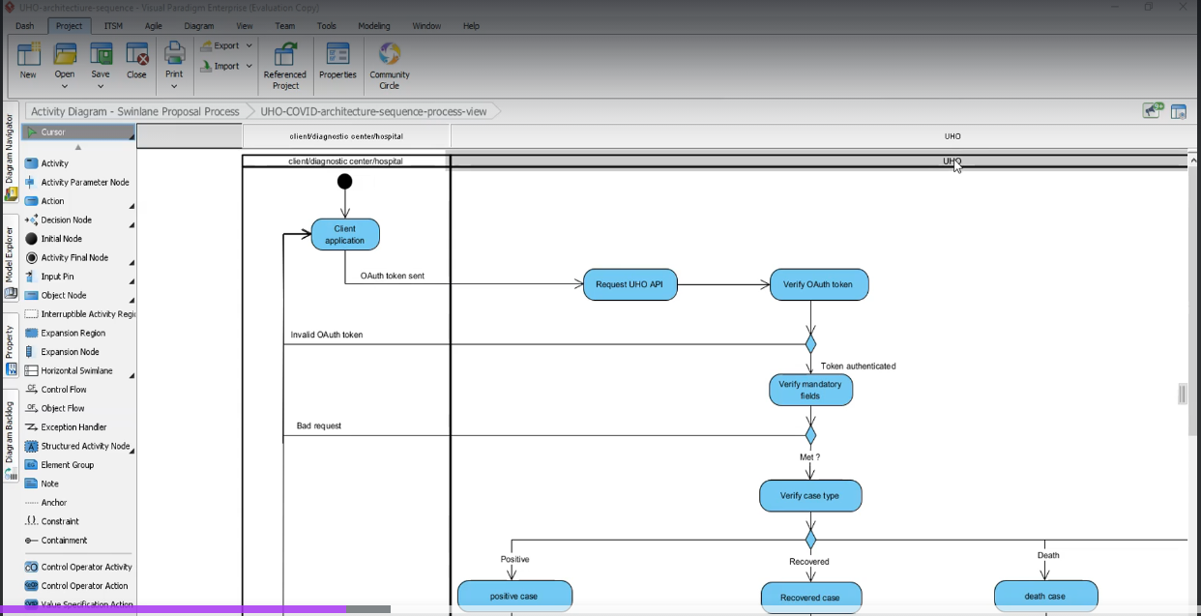 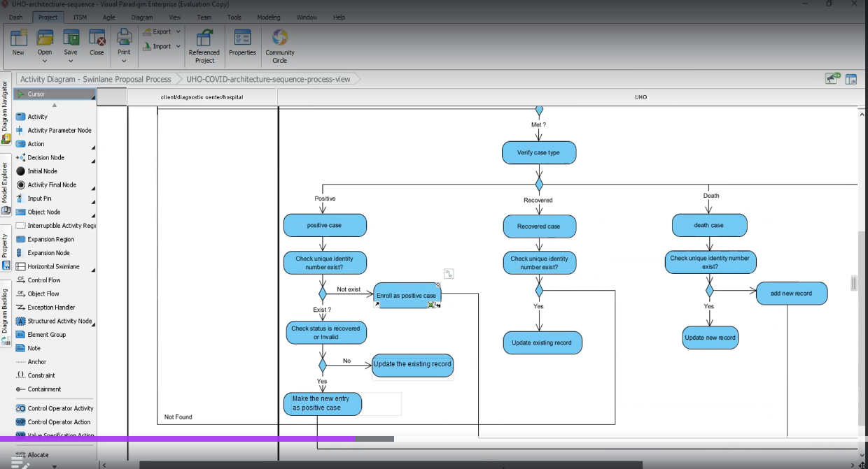 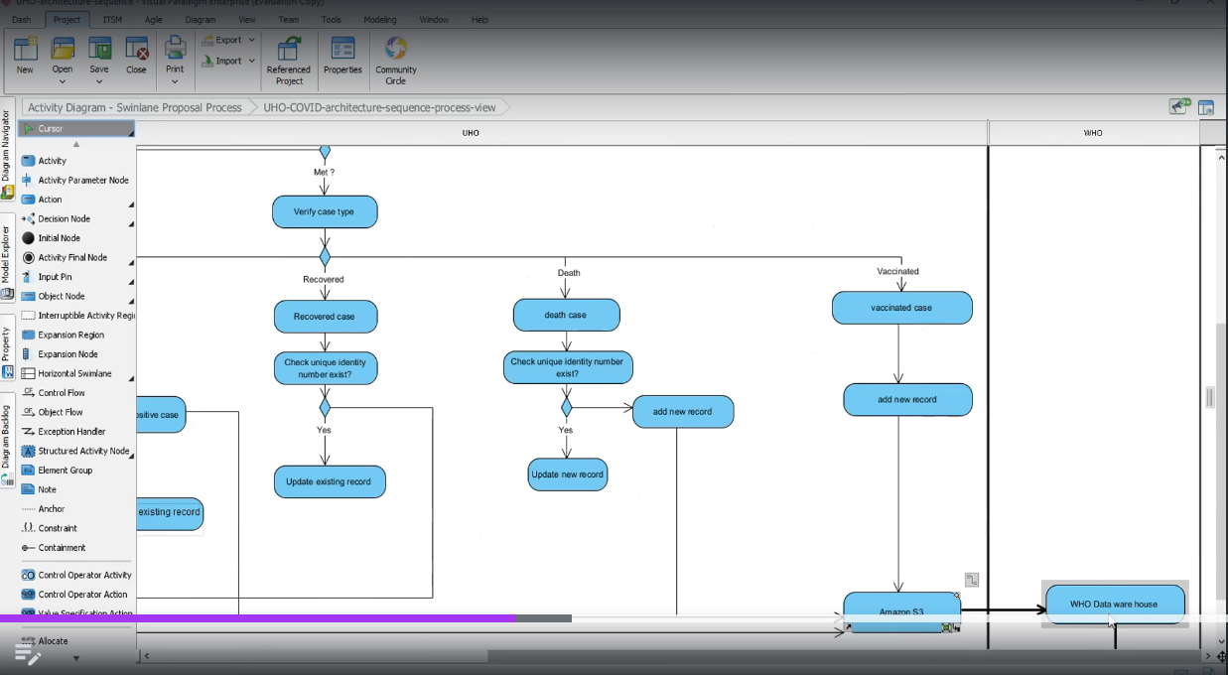

-Developer View Example(component View):

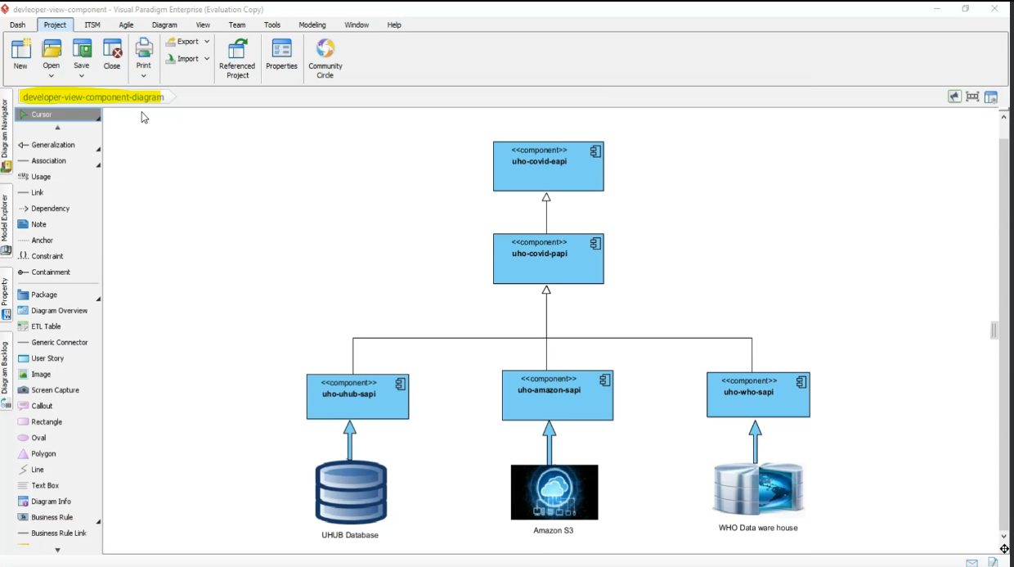

-Physical View Example(Deployment Diagram):

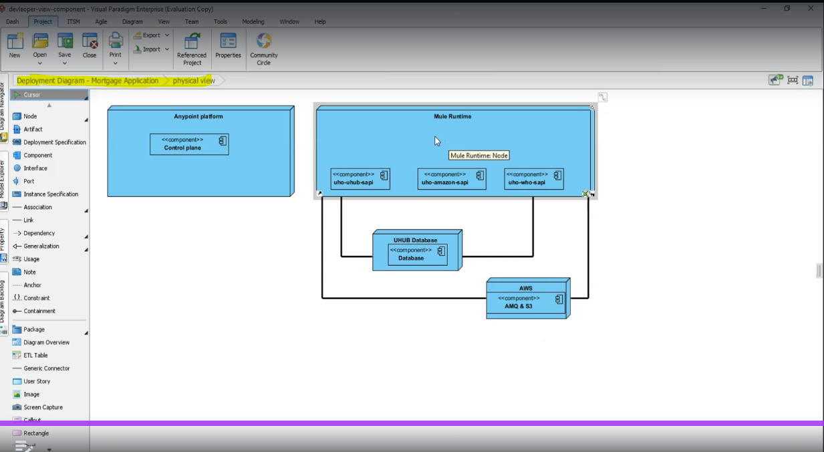

**Documenting Integration Solutions**

Refer this location for sample document

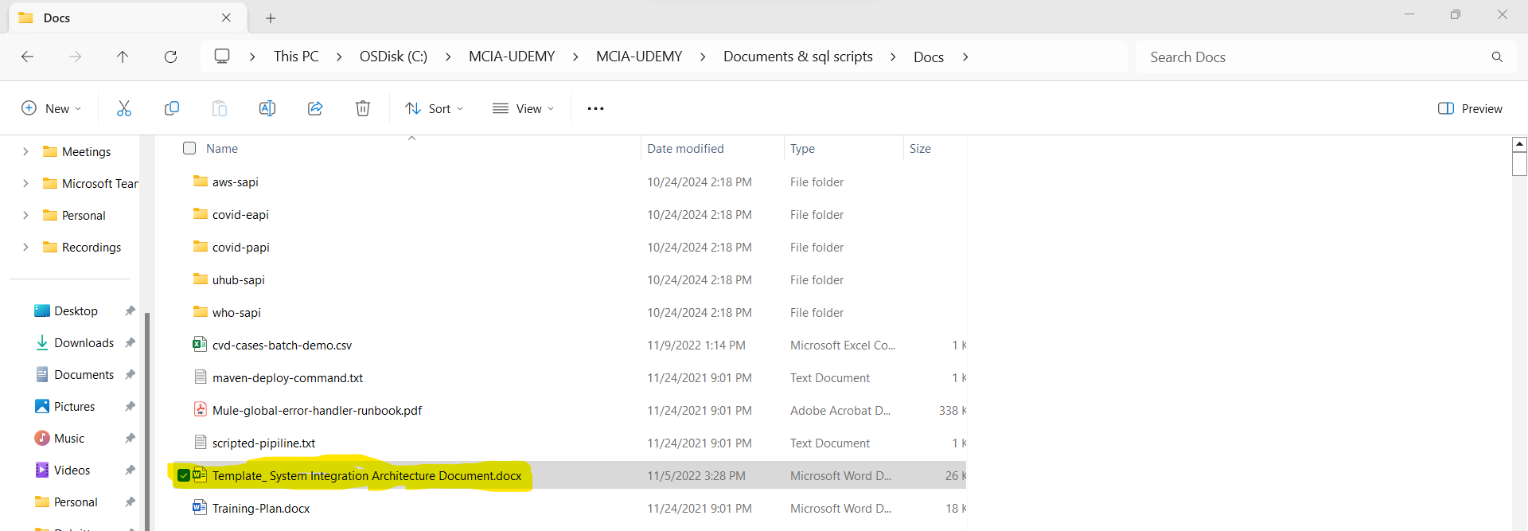

**Documenting Technical Design & Use Cases For Integration Solutions**